Database Normalization and ERD design
Legend – Bold = Primary Key
Italics = Foreign Key
BoldItalic = Primary Key/Foreign Key
Sales View
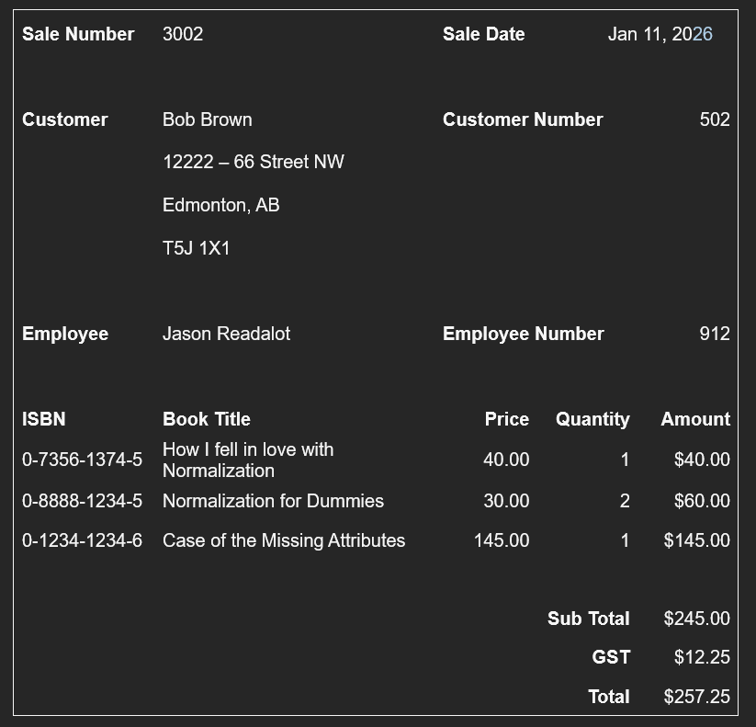
0NF
Sales (SaleNumber, CustomerName, CustomerNumber, SaleDate, Street, City, Province, PostalCode, EmployeeName, (ISBN, BookTitle, Price, Quantity, Amount), SubTotal, GST, Total)

1NF
Sales (SaleNumber, CustomerName, CustomerNumber, SaleDate, Street, City, Province, PostalCode, EmployeeName, SubTotal, GST, Total)
SaleItem (saleNumber, ISBN, BookTitle, Price, Quantity, Amount)

2NF
Sales (saleNumber, SaleDate, CustomerName, Street, City, Province, PostalCode, CustomerNumber, EmployeeName, SubTotal, GST, Total)
SaleItem (saleNumber, ISBN, Quantity, Amount)
Book (ISBN, BookTitle, Price) *

3NF
Sales (saleNumber, SaleDate, EmployeeName SubTotal, GST, Total)
Customer (CustomerNumber, CustomerName, Street, City, Province, PostalCode)
Employee (EmployeeNumber, EmployeeName)

Employee View
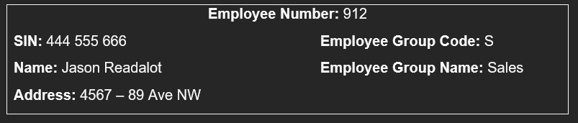

0NF
Employee (EmployeeNumber, EmployeeGroupCode, SIN, Name, Address, EmployeeGroupName)

1NF
- No repeating groups
Employee (EmployeeNumber, EmployeeGroupCode, SIN, Name, Address, EmployeeGroupName)

2NF
- No partial dependencies
Employee (EmployeeNumber, EmployeeGroupCode, SIN, Name, Address, EmployeeGroupName)

3NF
Employee (EmployeeNumber, SIN, Name, Address)
EmployeeGroup (EmployeeGroupCode, EmployeeGroupName)

Book Title View
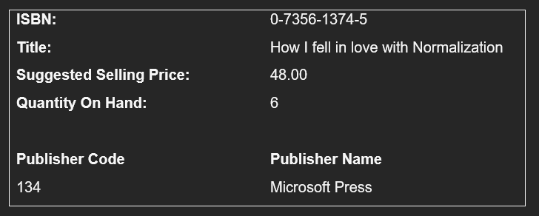
0NF
Book (ISBN, PublisherName, Title, SuggestedSellingPrice, QuantityOnHand, PublisherCode)

1NF
- No repeating groups
Book (ISBN, PublisherCode, PublisherName, Title, SuggestedSellingPrice, QuantityOnHand)

2NF
- No partial dependencies
Book (ISBN, PublisherCode, PublisherName, Title, SuggestedSellingPrice, QuantityOnHand)

3NF
Book (ISBN, PublisherCode, PublisherName, Title, SuggestedSellingPrice, QuantityOnHand)
Publisher (PublisherCode, PublisherName)

Merging
Sales (SaleNumber, CustomerNumber, EmployeeNumber, SaleDate, SubTotal, GST, Total)
SaleItem (saleNumber, ISBN, Quantity, Amount)
Customer (CustomerNumber, CustomerName, Street, City, Province, PostalCode)
Employee (EmployeeNumber, EmployeeGroupCode, EmployeeName, SIN, Address)
EmployeeGroup (EmployeeGroupCode, EmployeeGroupName)
Book (ISBN, PublisherCode, PublisherName, Title, SuggestedSellingPrice, QuantityOnHand)
Publisher (PublisherCode, PublisherName)

ERD
